Quotation Down Payment
User Guide

Tri-E Enterprises · TOS System · Quotations Module
Prepared: August 26, 2026

Overview
When you create a quotation, you can now record a down payment — an amount the customer has already paid toward it. This is completely optional. Leave it blank and the quotation works exactly as before.

When you do enter an amount, the system automatically works out the Balance Due (what the customer still owes) and shows it on:
- The quotation screen, while you're creating it
- The printed quotation you hand to the customer
- The quotation record in the admin panel

ℹ You can add a down payment whether the customer is a **walk-in** at the counter or the quotation is being entered as an **online transaction** through the admin panel. Both work the same way.

1. Walk-in Customers (POS)
Use this when a customer is at the counter and you're building their quotation from the cart.

- Add the customer's items to the cart as usual.
- Click Create Quotation.
- In the window that opens, set Valid For (Days) if you want a different validity period than the default.
- If the customer is paying something now, enter the amount in Down Payment (Optional).
- The Balance Due below it updates automatically — that's what the customer will still owe.
- Add any Notes, then click Create & Print.

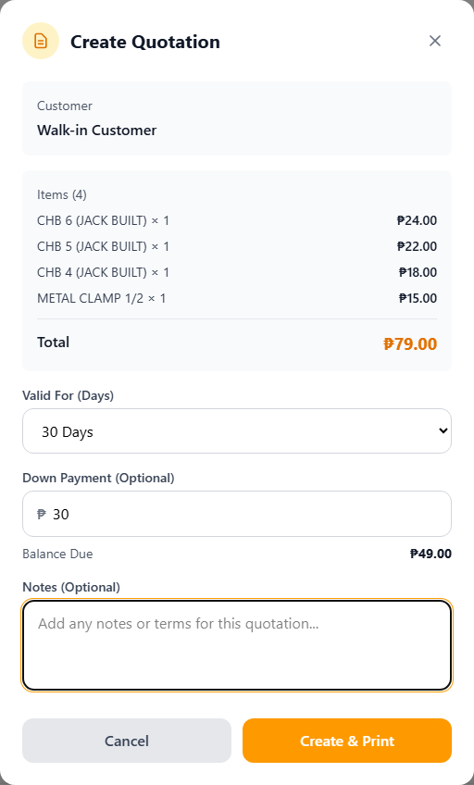
Example: ₱79.00 total, ₱30.00 down payment entered → ₱49.00 balance due
ℹ You can't enter more than the total — if you type a bigger number, it's automatically capped at the quotation total.

2. Online Transactions (Admin Panel)
Use this when you're entering a quotation directly in the back office rather than through the POS cart — for example, for an online inquiry or a phone order.

- Go to Inventory & Sales → Quotations and click Create (or open an existing quotation and click Edit).
- Fill in the customer, date, and items as usual.
- In the Quotation Summary section, enter an amount in Down Payment (Optional) if the customer has already paid something.
- The Balance Due next to Total Amount updates automatically.
- Click Save changes.

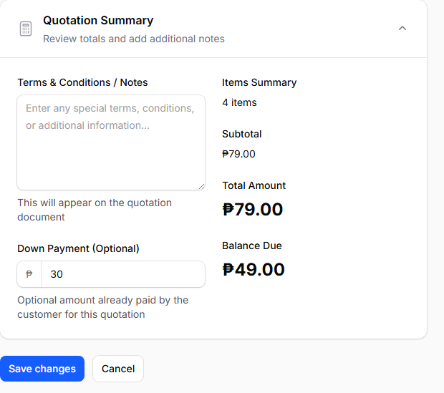
Quotations → Edit → Quotation Summary
ℹ Just like in the POS, the down payment can't exceed the quotation total — it's automatically capped when you save.

3. What the Customer Sees on the Printed Quotation
If a down payment was entered, the printed quotation automatically shows two extra lines under the total — Down Payment and Balance Due — so the customer has a clear record of what they've paid and what's left.

If no down payment was entered, the printed quotation looks exactly as it always has — no extra lines are added.

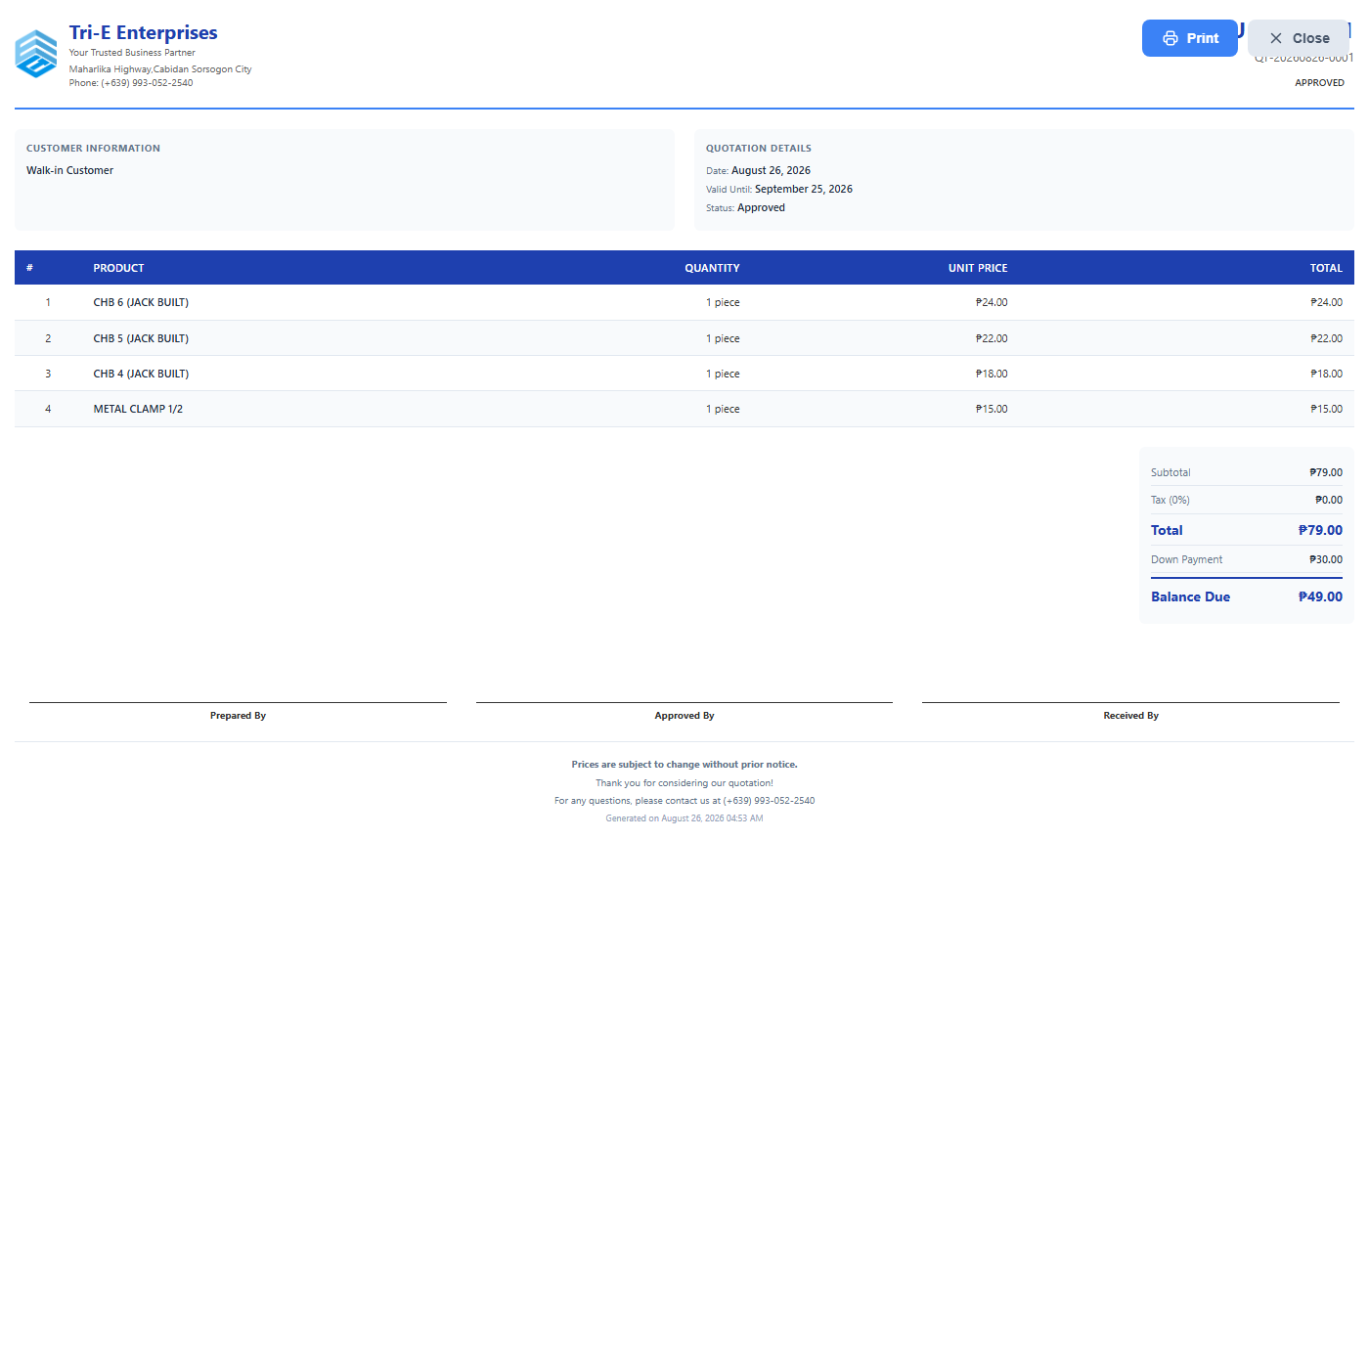
Printed quotation with a down payment recorded

4. Good to Know
- *It's always optional.** Skip it and the quotation behaves exactly as before — no down payment, no balance shown.
- *It can't exceed the total.** If you enter more than the quotation total, it's automatically reduced to match.
- *It carries over on conversion.** If an approved quotation with a down payment is converted into a sale at the POS, the down payment amount is already filled in for you — no need to re-enter it.
- *Existing quotations aren't affected.** Any quotation created before this feature shows a down payment of ₱0.00 and a balance equal to the full total.

Tri-E Enterprises · TOS System

